European Seed Treatment Assurance Scheme (ESTA)
Enquiry Form

Company Name | Contact Name
Company Address  Post Code: | Tel
Company Address  Post Code: | Fax
Company Address  Post Code: | Mobile
Company Address  Post Code: | Email
Operational Site address (if different from above)

Post Code:
Number of Sites to be included within the certification  (Please list sites and site activities below) |  | No
Existing Approvals - Please list current approvals and the Audit Bodies that you use;

Please indicate if you wish one of these Audit Bodies to carry out your ESTA assessment at the same time as your other approval audits  Yes  No Kiwa Agri Food will liaise with you over the appointment of the Audit Body.

Site details | Site activities

I understand that we must pay the AIC Registration Fee and the audit/certification fee. Based on the information provided in this Application Form, Kiwa Agri Food will send a Quotation with details of the audit/certification and AIC Registration fees.

I expect to be ready for my Assessment during ……………………. (month/year)
(Note- You must have an audit within 6 months of issue of a formal quotation)
Signed Position Date
Please complete and return to Kiwa Agri Food, The Inspire, Hornbeam Square West, Harrogate HG2 8PA

Reasons for choosing/remaining with Kiwa Agri Food (please circle)

Marketing, Referral, Quality, Speed, Price, Customer Demand, Google Search

OFFICE USE ONLY  Client Code:  Allocated to: | Proposal Set Up:  Allocated time:  Fee:
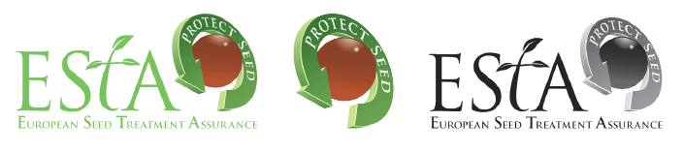
SF.203 rev 01

